**NATIONAL INSTITUTE OF TECHNOLOGY**

**KURUKSHETRA**



**PRACTICAL FILE**

**SUBJECT :-** **Programming Using Python**

**BRANCH :- CS-A-01**

**ROLL NO :- 12112003**

**Submitted to:-**

**Shweta Pandey mam**

**Submitted by:-**

**Priyanshu maurya**

**Experiment-5**

1. Write a Python program to convert a string in a list.

string=input("ENter a string : ")

l=*list*(string)

print

OUTPUT



1. Write a Python program to find the first repeated word in a given string.

string = input("Enter a multi-word String: ")

for i in string.split(" "):

    if string.split(" ").count(i) > 1:

        print("First repeated word is", i)

        break

OUTPUT

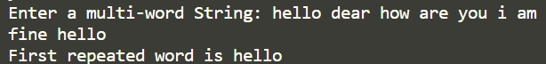

1. Write a Python program to find all the common characters in lexicographical order from two given lower case strings. If there are no common letters print "No common characters".

str1 = input("Enter string 1: ")

str2 = input("Enter string 2: ")

lex = ""

for i in str1:

    if i in str2:

        lex = lex+i

if len(lex)==0:

    print("No common character found.")

else:

    print("".join(sorted(lex)))

OUTPUT

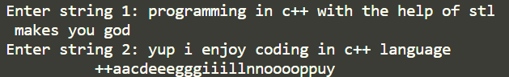

1. Write a Python program to create two strings from a given string. Create the first string using those characters which occurs only once and create the second string which consists of multi-time occurring characters in the said string.

string = input("ENter a string : ")

str1 = ""

str2 = ""

for i in string:

    if string.count(i) == 1:

        str1 = str1+i

    else:

        if str2.count(i) == 0:

            str2 = str2+i

print("String having Characters occuring once is '", str1, "'")

print("String having Characters occuring more than once is '", str2, "'")

OUTPUT

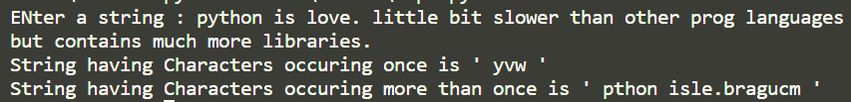

1. Write a Python program to find the index of a given string at which a given substring starts. If the substring is not found in the given string return 'Not found'.

string = input("Enter a string : ")

sub = input("Enter a substring : ")

ind = string.find(sub)

if  ind != -1:

    print("Found at index",ind)

else:

    print("NOt found")

OUTPUT

